File design integration

To integrate mockup files in “Acted” project we get HTML, CSS and JS files from Mock up repository and use them as base for our views

For example, right is spotlights from mockup files and left is our spotlights:

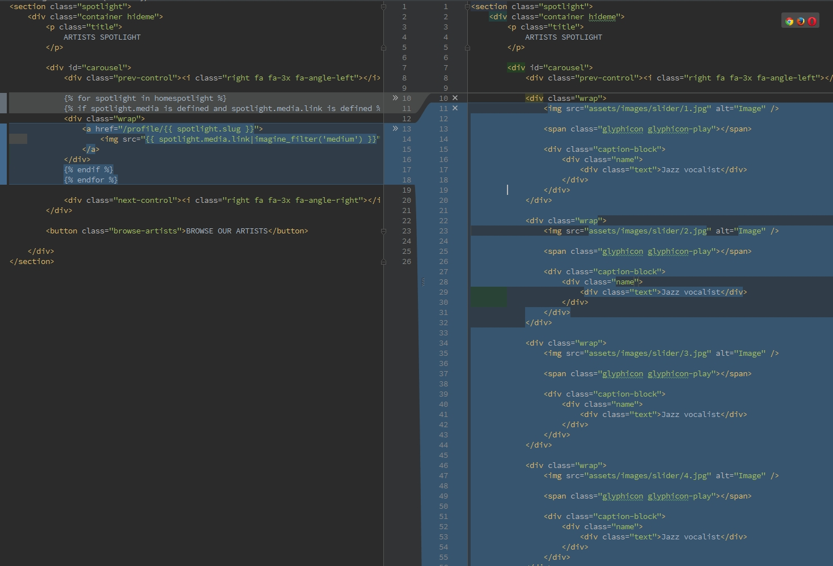

In our templates we use “Twig” <http://twig.sensiolabs.org/>

Twig is default template engine in Symfony2.

We have css and js files in *src/Acted/LegalDocsBundle/Resources/public*

Then I create single css and js file using Gulp and place it in “web” directory.

In this case browser makes less requests to server because downloads just one css and one js file.

<http://gulpjs.com/>

It is needed to install gulp to create new final css and js files. If Gulp is installed on your server you just need to start it in console with “gulp” command in your project directory. Gulp options file is located in project directory in “gulpfile.js”.

How to use “Gulp”

1. Install node.js on server  
apt-get install nodejs

2. Install npm on server

apt-get install npm

2. Install gulp on server

npm install gulp -g

3. Run ‘gulp’ command in console in project directory.

If there will be problem with gulp running gulp because of missing some modules you can install them with “npm install <moduleName>”

How we merge css and js from mockup repository

When we get new css and js files we compare them with our current files (with a diff tool) and look at the changes from design team.

If these changes are affecting only design and will not break anything we embed them to our files.

If files from mockup are new ones we just add them to our project (in src/Bundle/...).

If new css or are necessary, the best way is to create new files (for example : “customNew.css”) and place them in folder that you need.

Gulp will get them together in one file. The **gulpfile.js** shall be updated if necessary